Case 1

A 62-year-old lady attended your AED for dizziness and generalized weakness for 1 day. She was fully conscious. Her blood pressure was 160/78mmHg and pulse was 78bpm. 4 limbs power 5/5. When examining on the presence of nystagmus, you saw this
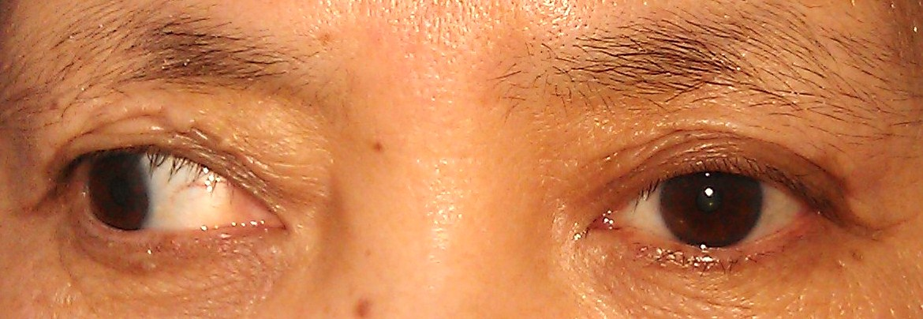

Q1. Describe the eye position(1).What is this clinical condition (1)?
A1. Right eye in outward and downward position (1).Right oculomotor nerve palsy (1)

Q2. What does the nerve supply (3)?
A2. Superior rectus, medial rectus, inferior rectus, inferior oblique, levatorpalpebraesuperioris, parasympathicfibres to the ciliary ganglion (which innervates the sphincter pupillae and ciliary muscles)(0.5 each)

Q3. Give 4 causes of the above condition (2). How to distinguish medical and surgical causes of the condition (1)?
A3. DM, HT microangiopathy causing nerve ischemia
Posterior communicating artery aneurysm
Trauma – head injury with SDH/ EDH causing uncal herniation; orbital injury
Pituitary tumour, apoplexy; Meningioma
Cavernous sinus thromosis, carotid-cavernous fistula
Giant cell arteritis
Demylinating disease – multiple sclerosis;Miller-Fisher syndrome
Idiopathic ~25% (0.5 each)
Pupil-sparing in medical cause (1)

The patient was admitted to medical ward and later developed ataxia and absence of knee jerk and ankle jerk.
Q4. What syndrome is characterized by triad of ophthalmoplegia, ataxia and areflexia (1)?
A4. Miller Fisher syndrome (1)

Q5. If the patient develops bulbar weakness with swallowing disturbances, severe tetraparesis or respiratory failure, what treatment (other than supportive) can be given (1)?
A5. Intravenous immunoglobulin, plasmapheresis (0.5 each)

Case 2

A 71-year-old man was found lying on floorof kitchen with confusion. He was suspected to take 40mls of 拳頭油(39% wintergreen oil) about 6 hours ago.His GCS was E3V1M5, blood pressure 154/90, pulse 100/min, respiratory rate 28/min, SpO2 100% while on 2L/min oxygen, temperature 35.4ºC. Here attached the medicinal oil photos and his ABG result.
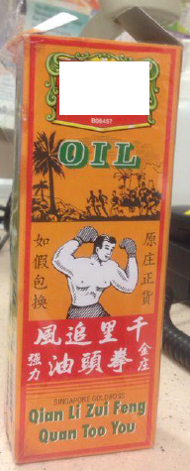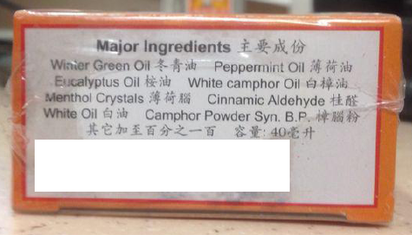
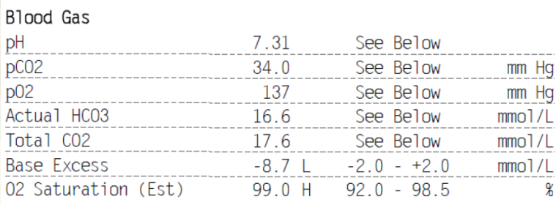
Q1. What is the patient suffering from? (1)
A1. Methyl salicylate poisoning (1)

Q2. Name 3 investigations in A&E and the respective reasons for the investigations (3)
A2.1. CXR to look for aspiration, 2. serum salicylate level every 2-4 hours till 2-3 consecutive falling levels to monitor clearance of salicylate; 3. Serum electrolytes to exclude hypokalemia or to calculate anion gap; 4.Hemoglucostix or blood sugar to exclude hypo or hyperglycemia; (any 3; no marks for ABG because it is already given)

Q3. Name the gastrointestinal decontamination method(s) that may be used in this patient. (1)
A3. MDAC if serum salicylate level remains high (1) (No gastric lavage, no single dose activated charcoal, no whole bowel irrigation in this patient)

Q4. What is the recommended drug that may help this patient and the purpose of giving this drug? (2)
A4. NaHCO₃(1) for serumand urinary alkalization (1)

Q5. Name one treatment for this patient if the above measures fail. (1)
A5. Extracorporeal removal by hemodialysis or hemoperfusion (1)

Q6. What other ingredients of this medicinal oil can also contribute to CNS toxic effects? (2)
A6. Essential oils (1) and hydrocarbons (1)

Case 3

A 73-year-old man attended an A&E Department for left sided low back pain for one week. He claimed that he might have lifted heavy weights before the onset of the pain.X-ray of lumbosacral spine was done.The pain was relieved by an injection of NSAID (Toradol).
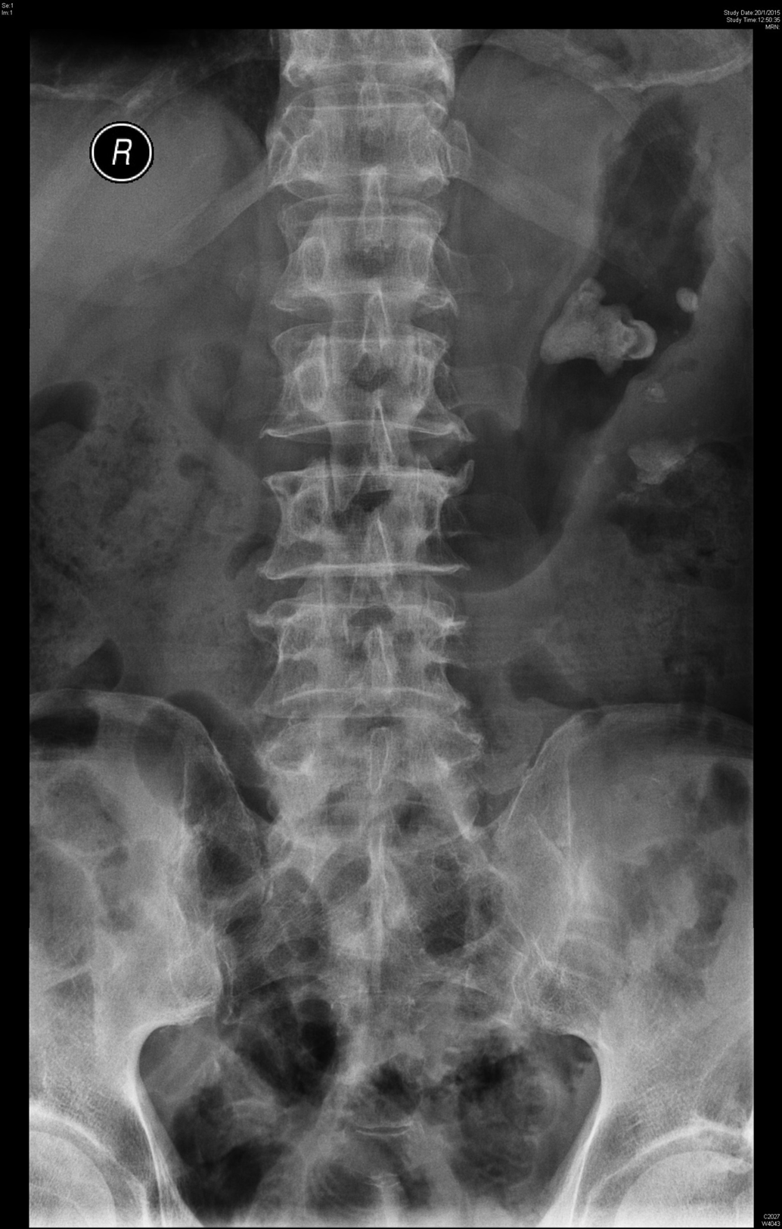
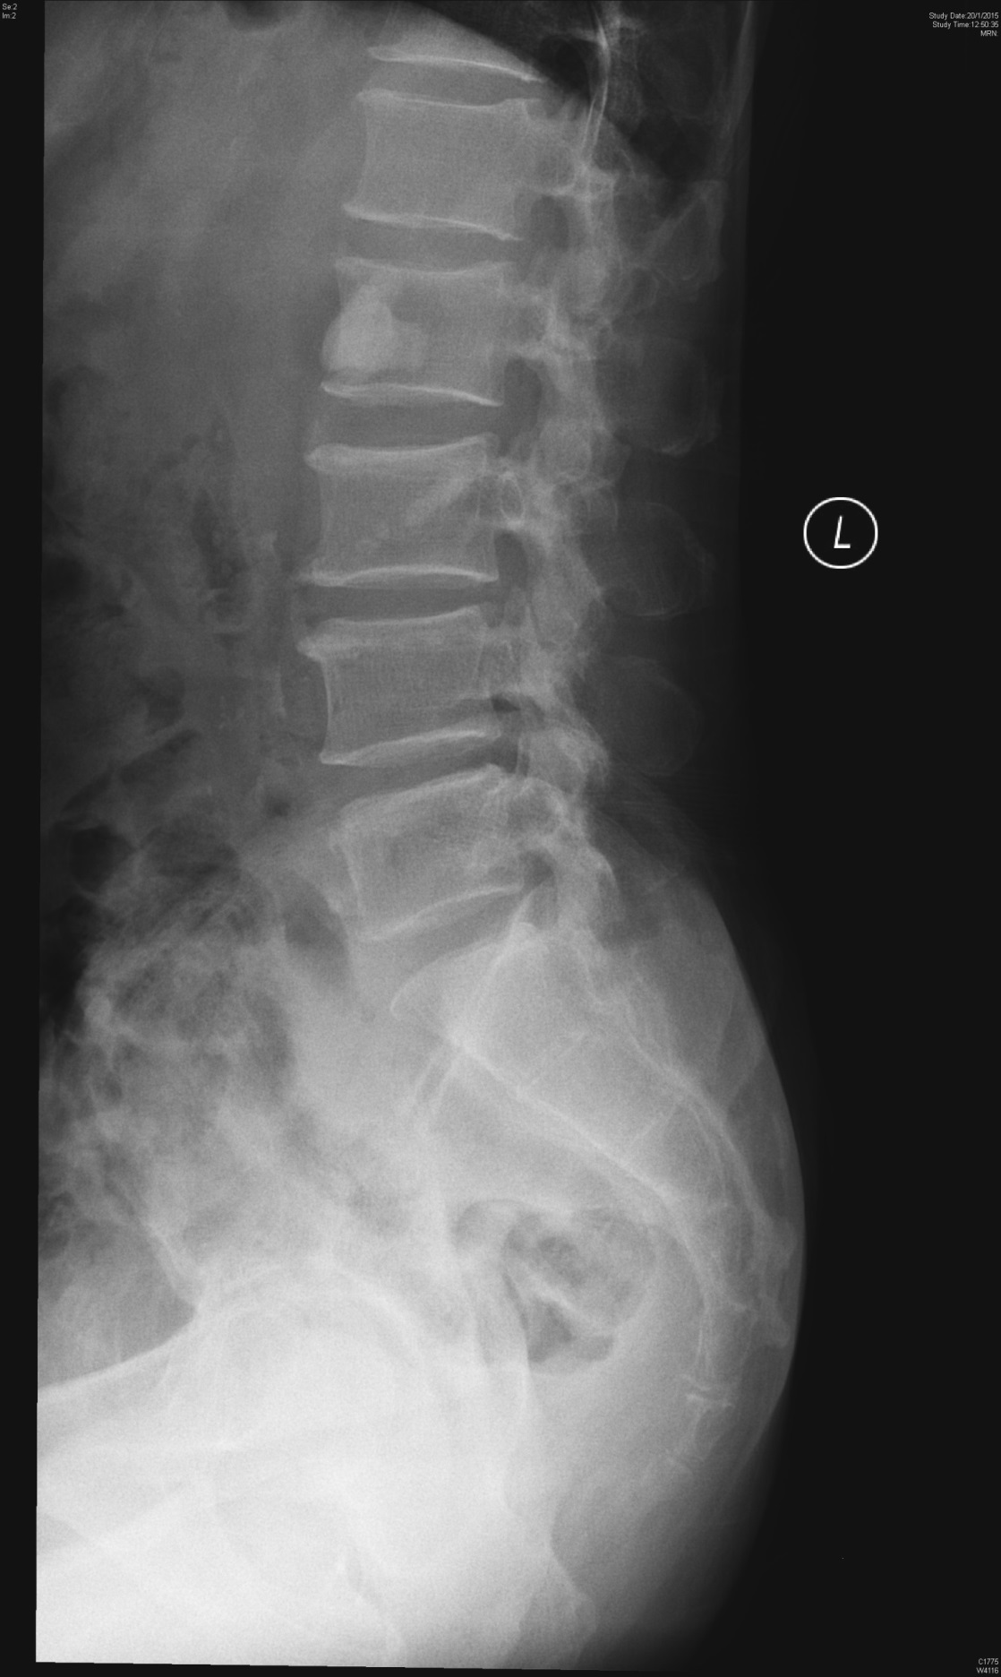
Q1. What are the radiological findings of the X-ray ? (2)
A1.Left staghorn kidney stone (1); mild degenerative changes of lumbar vertebrae with disc spaces preserved (1).

Q2. Name two investigations in A&E that might help you determine the urgency of his problem. (2)
A2.Bedside USG kidneys; RFT; MSU x culture (any 2; 1 each) (no marks for urine x RBC)

Q3. Name two classes of drugs you might give to the patient on discharge. (2)
A3. Analgesics (NSAID) (1), antibiotics (if UTI is present) (1)

Q4. Name two conditions that might precipitate the problem in the patient. (2)
A4. Hypercalcemia, recurrent UTI, hyperoxaluria, renal tubular acidosis, cystinuria, Fanconi syndrome, etc(any 2; 1 each)(no marks for hyperuricemia because uric acid stone is radiolucent)

Q5. Name two definitive treatments for his problem other than open surgery. (2)
A5. Percutaneous nephrolithotomy (PCNL) (1), extracorporeal short-wave lithotripsy (ESWL) (1)

Case 4
This question is about called back patients.

A 43-year-old taxi passenger at back seat was sent to the A&E Department by ambulance after a traffic accident. His forehead hit against front seat when the taxi braked suddenly. He was fully conscious with laceration wounds on left side of forehead. The wounds were closed. Skull X-ray was done as shown and was interpreted by the case doctor as unremarkable. He was then discharged with head injury advice.
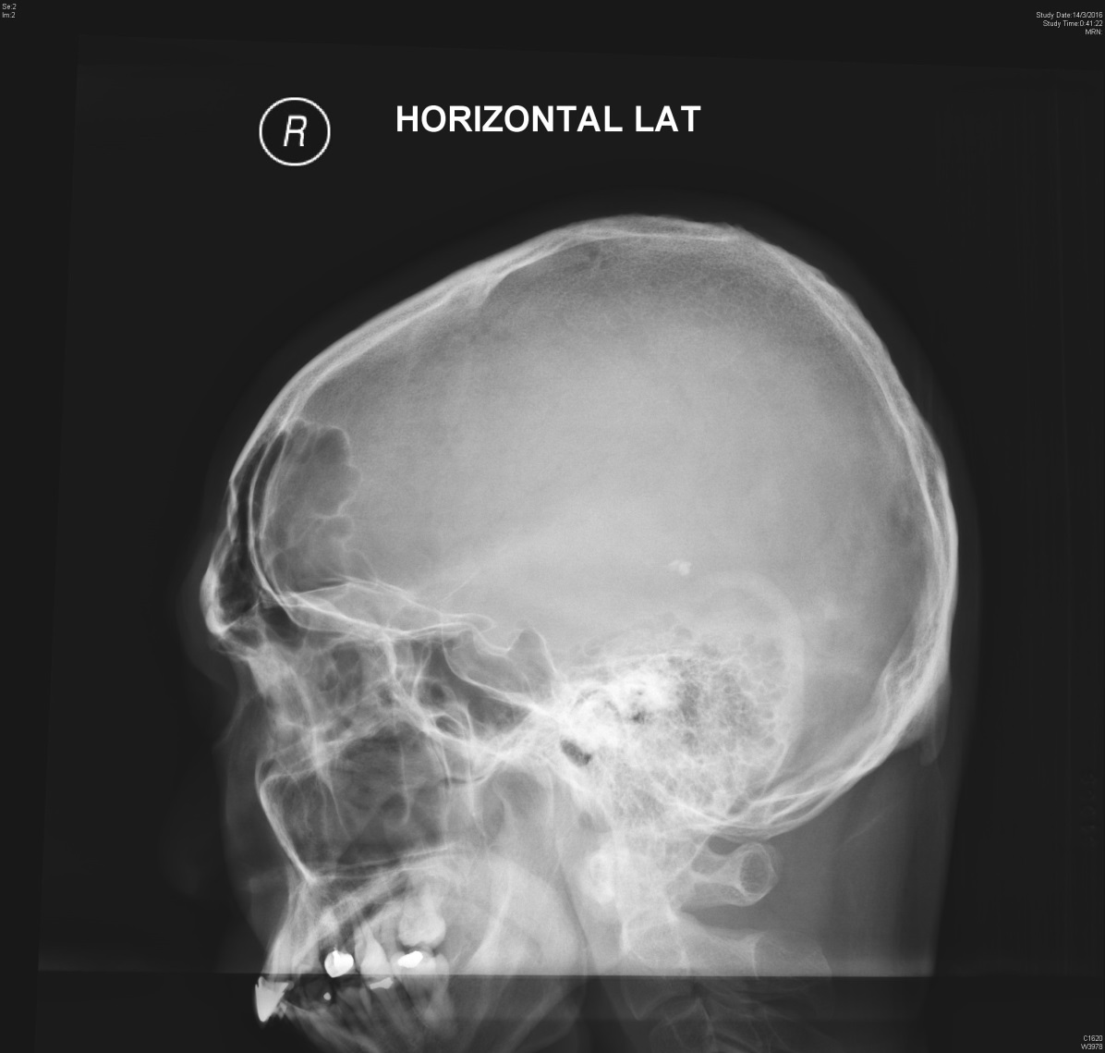

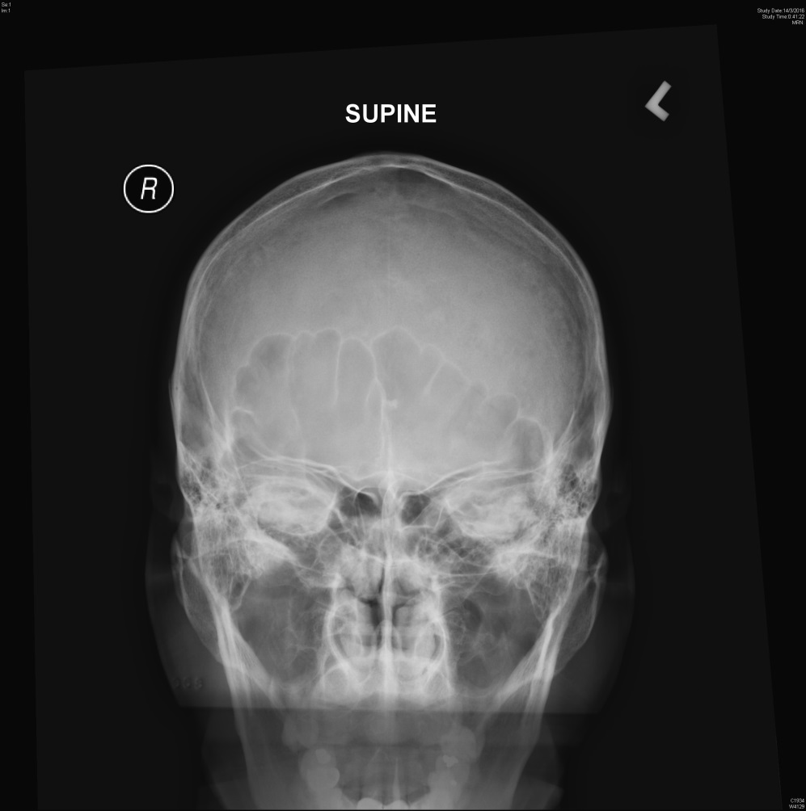
The X-ray images were later screened by senior doctor and the patient was called back for further management.
Q1a. What is the missed X-ray finding? (1)
A1a. Depressed frontal skull bone (1)

Q1b. What further investigation would you like to do? (1)
A1b. CT scan of brain and orbit (1)

A 52-year-old female was hit by a wooden board at her left face. Physical examination found bruise over her left infraorbital area. X-ray of orbits were done and found no fractures by the case doctor. She was discharged with pain killer.
She was called back after X-ray screening.
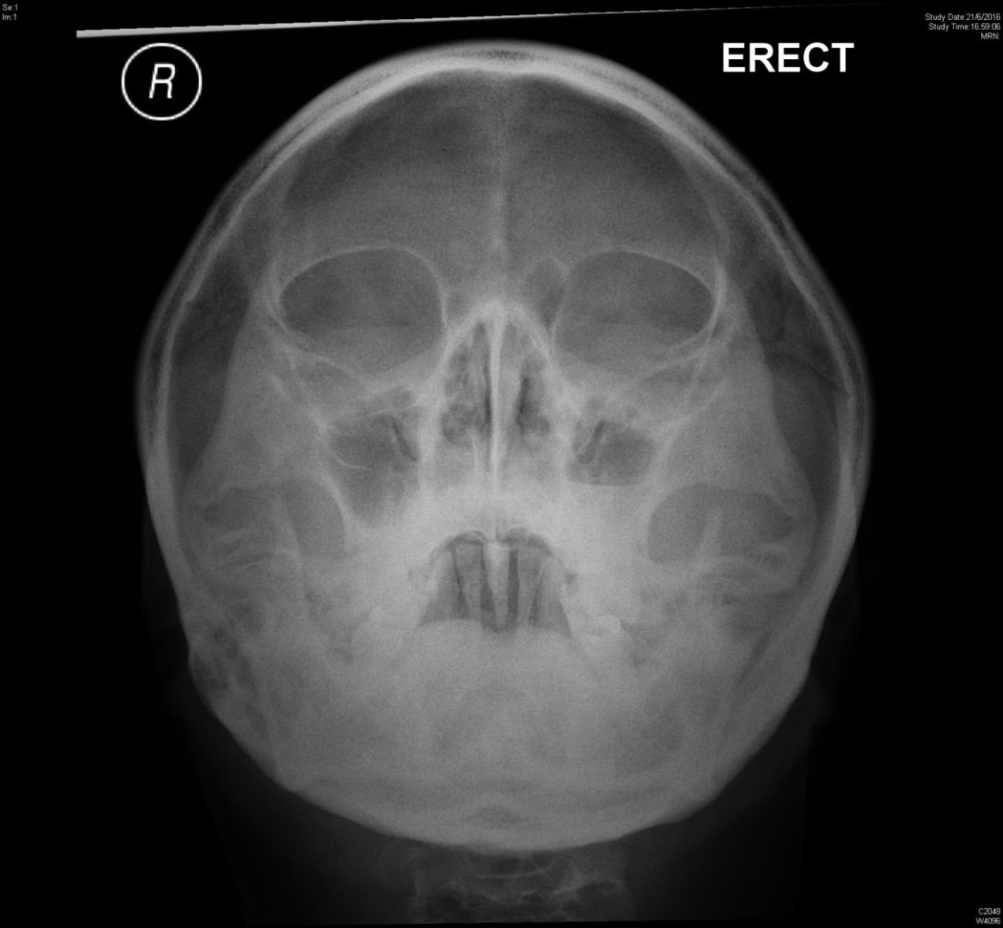
Q2a. What is the missed radiological finding? (1)
A2a. Fluid level at left maxillary sinus (1)

Q2b. What eye sign should be excluded? (1)
A2b. Diplopia on looking up (entrapment of left inf rectus muscle) (1)

Q2c. Which nerve should be examined carefully in this patient? (1)
A2c. left inferior orbital nerve (1)

Q2d. What further investigation would you like to do? (1)
A2d. CT scan of maxillary sinuses and orbits (1)

A 5-year-old girl with good past health attended A&E Department for fever of one day. She had some cough and sore throat. Chest X-ray was done and found clear lung fields by the case doctor. She was discharged with symptomatic treatment for upper respiratory tract infection.
She was called back for further management after X-ray was screened by senior.
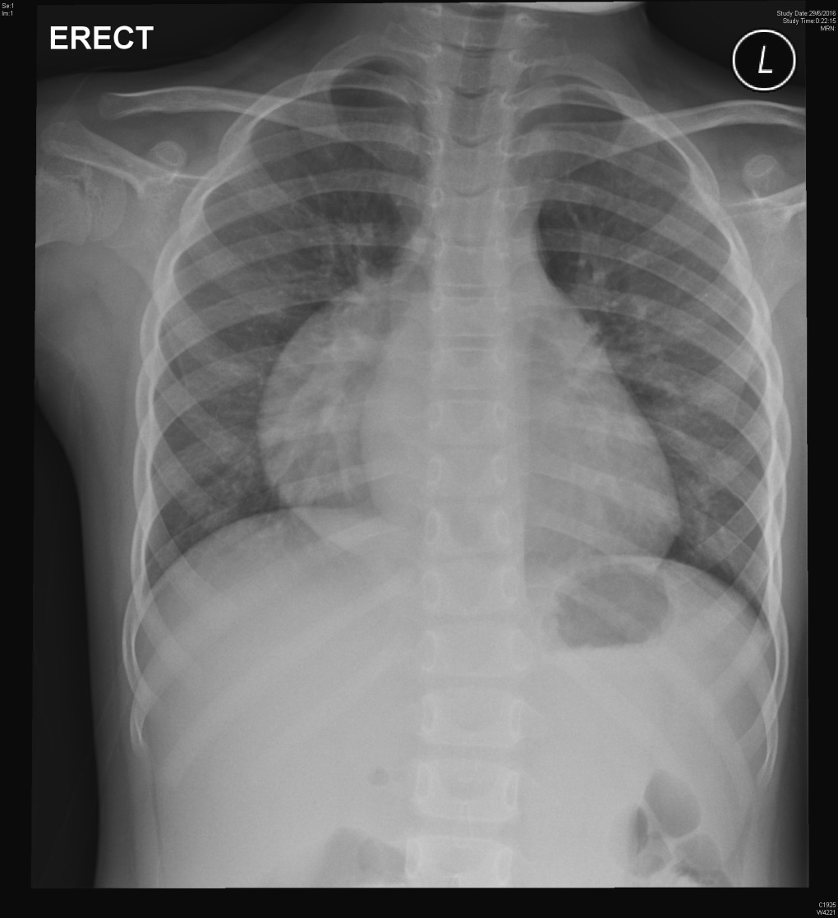
Q3a. What is the missed X-ray finding? (1)
A3a. Globular mass behind right heart – right posterior mediastinal mass(1)

Q3b. What further investigation can be done in your A&E Department to confirm your finding? (1)
A3b. Right lateral chest X-ray (1)

A 52-year-old female sprained her left foot when she fell downstairs on 4-Jan-2016. There was pain and swelling at left foot dorsum and she had difficulty to bear weight on left foot. X-ray of left foot was done and found unremarkable by the case doctor. She was discharged with pain killer and advice on R.I.C.E therapy. She re-attended A&E for few more times for persistent left foot pain and swelling on left foot dorsum in the next 6 weeks. She was finally admitted to Orthopedic Ward with operation done.
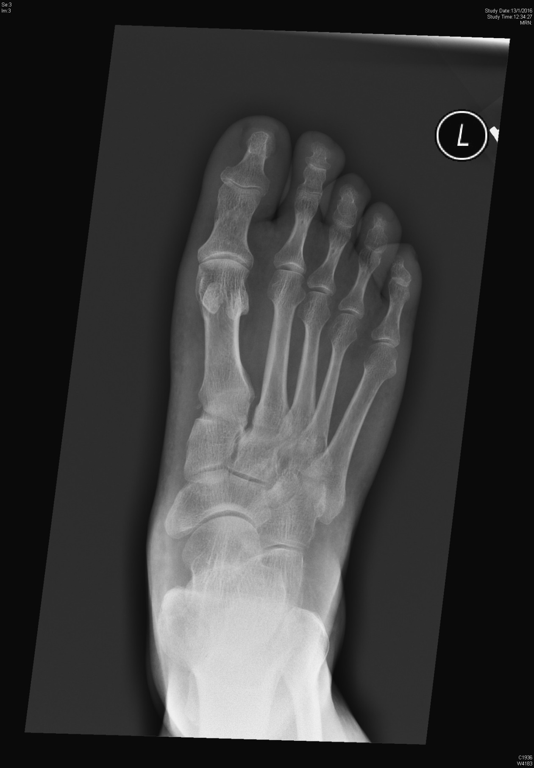
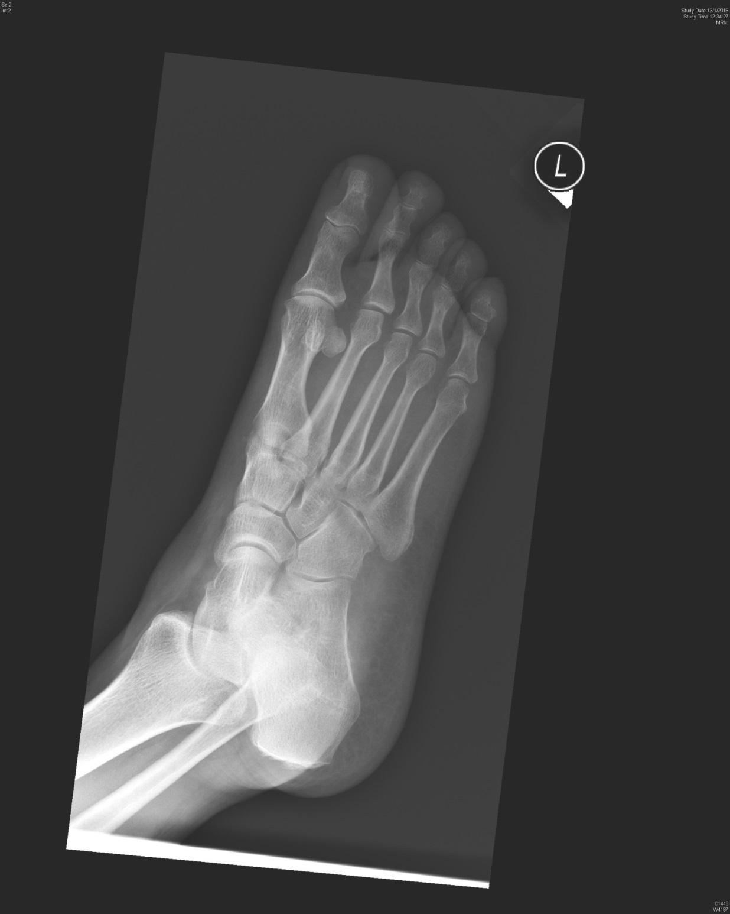
Q4a. What is the suspected missed X-ray finding? (1)
A4a.Increased gap between 1st and 2nd MT base (1)

Q4b. What is the likely diagnosis that requires operation in this patient? (1)
A4b.Lisfranc fracture (1)

